Vectors FAQ 1
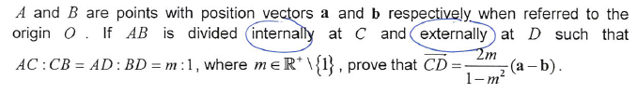
Solution
