Periodicity FAQ 2
The chlorides of the elements sodium to phosphorous are separately added to water. Which of the following diagrams best represents the pH of the solutions produced?
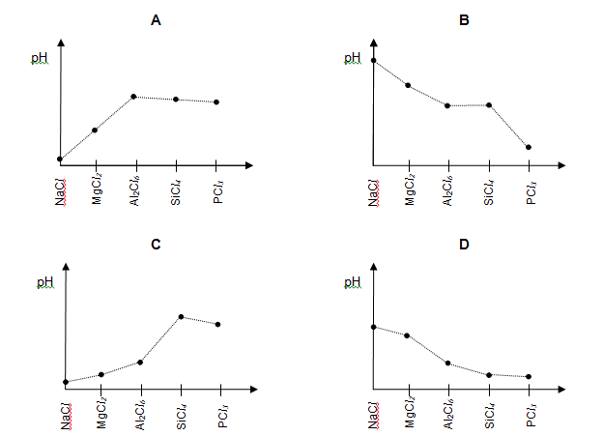
Solution
