Periodicity FAQ 1
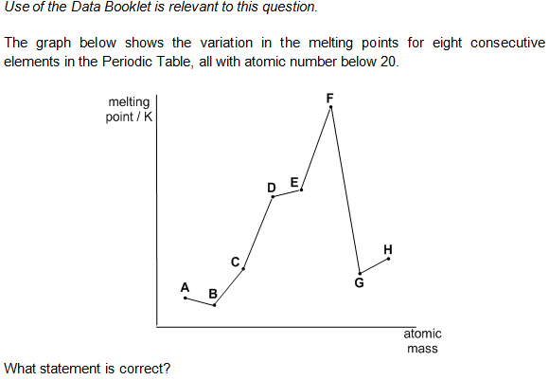
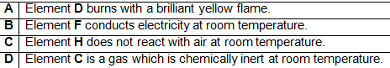
Solution
