Halogen Derivatives FAQ 12
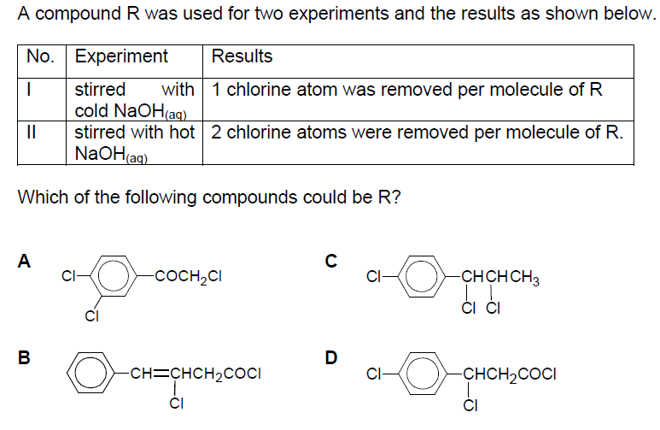
Solution
D

