Halogen Derivatives FAQ 1
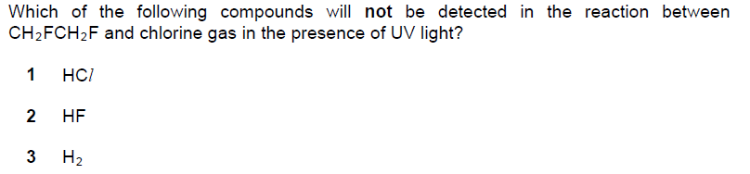
Solution
