Elements, Compounds and Mixtures FAQ 5
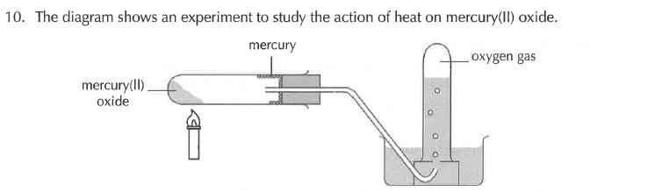

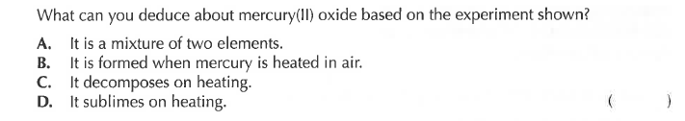
Solution
