Elements, Compounds and Mixtures FAQ 4
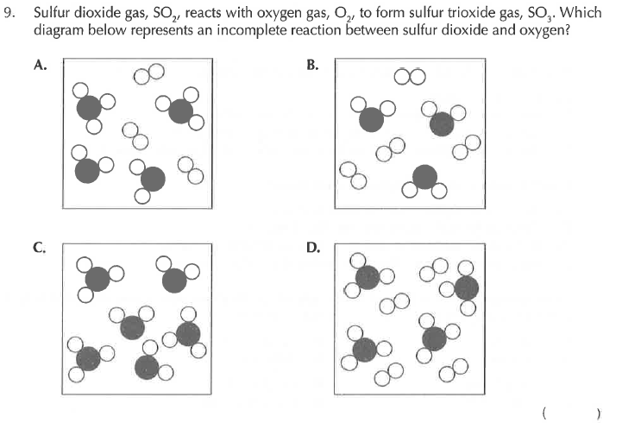
Solution
