Elements, Compounds and Mixtures FAQ 3
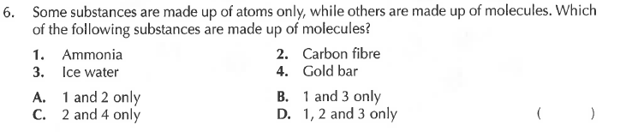
Solution

