Elements, Compounds and Mixtures FAQ 2
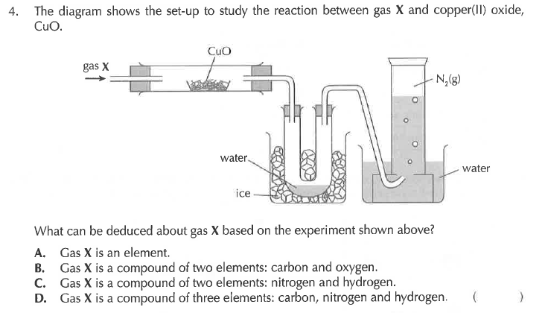
Solution
