Elements, Compounds and Mixtures FAQ 1
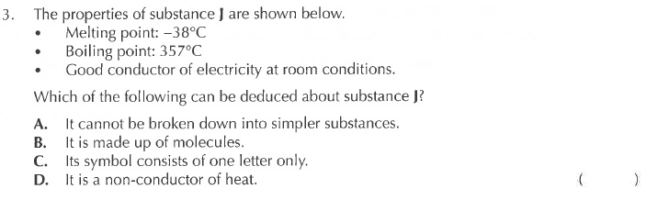
Solution
