Alkanes FAQ 8
2011 TJC P1 Q29 Prelim
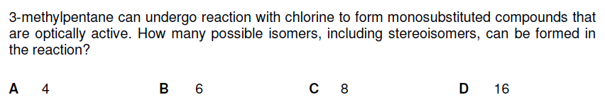
Solution
