Alkanes FAQ 7
2011 HCI P1 Q20 Prelim
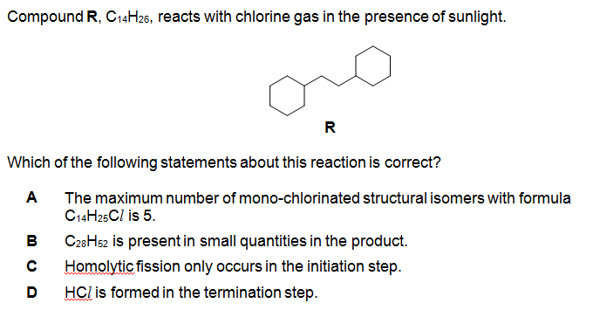
Solution
