Alkanes FAQ 6
2010 NYJC P1 Q23 Prelim
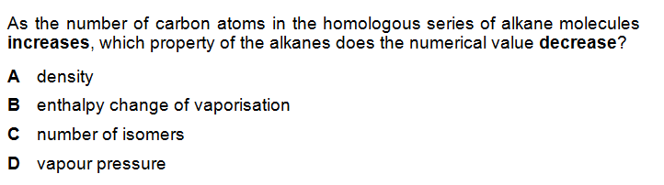
Solution
