**Chemical Equilibrium FAQ 1**

**Question 1**

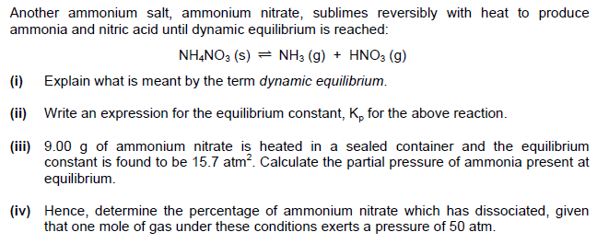

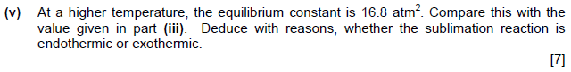

**Solution**

