30min Recurrence & Relationship Nugget 2
Question 1
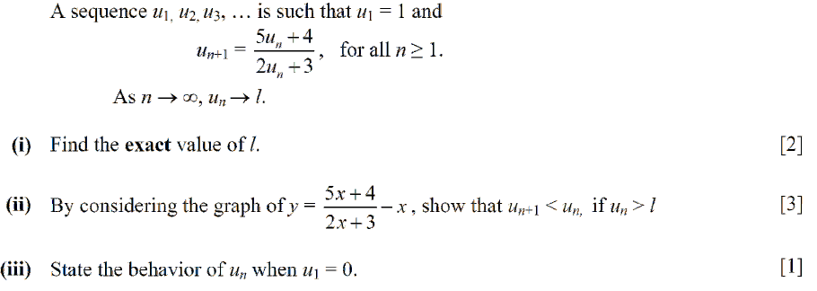
Question 2
