30min Recurrence Relations Nugget 1
Question 1
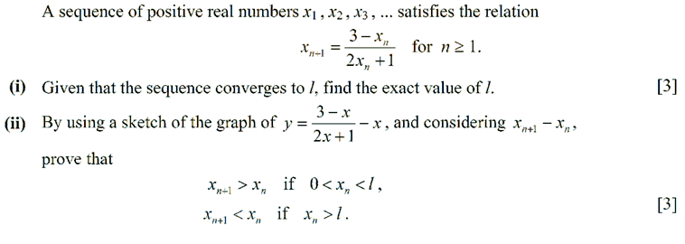
Question 2
