30min MOD Nugget 2
Question 1
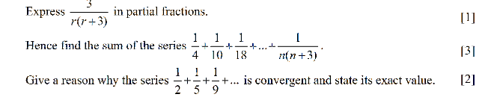
Question 2
