30min MOD Nugget 1
Question 1
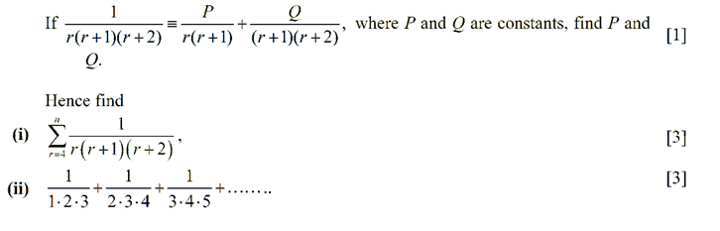
Question 2
