30min Inequalities Nugget 2
Question 1
Question 2
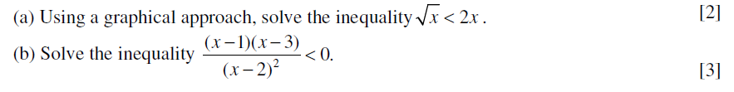
Question 3
