30min Inequalities Nugget 1
Question 1
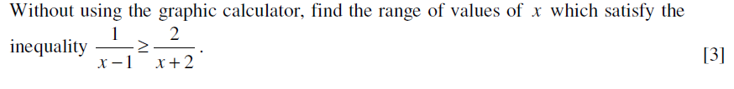
Question 2
Question 3

