**30min AP & GP Nugget 2**

**Question 1**

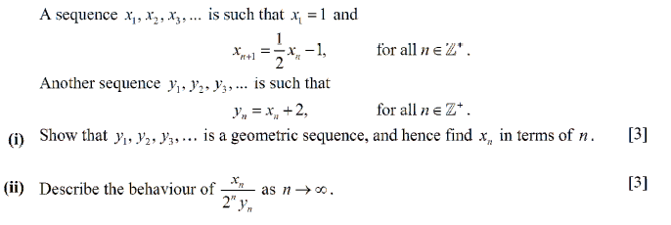

**Question 2**

