30min AP & GP Nugget 1
Question 1
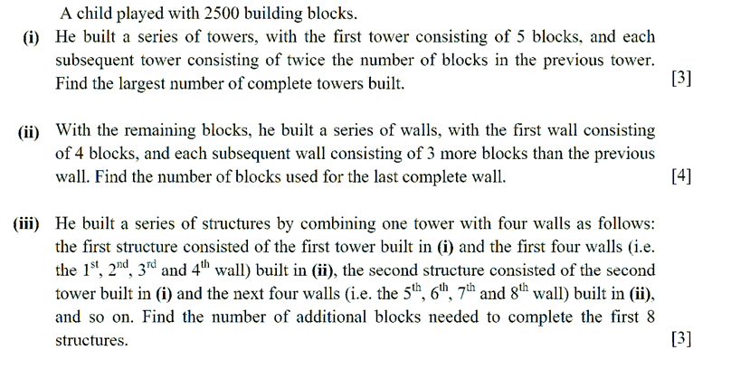
Question 2
